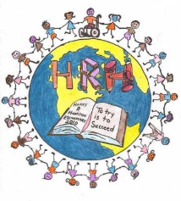

HRH Primary Supply List 2023-2024

Your child will need a lunch bag and a sturdy backpack that is big enough for a binder to fit in. They will also need a pair of non-marking sneakers to be left at school for the year. (Velcro is needed if your child is not yet able to tie laces). We recommend an extra set of clothes to be kept at school in a large Ziploc bag or a shoe box. Please don’t forget to label all of these items with your child’s name.
It is important that all of the items are as close to the list as possible and are very generic (eg. No Disney or TV characters). Please try to get the materials in the colours mentioned, as it makes it much easier to organize the classroom and for students to be independent with their materials. Thank you very much for your help and support!
- **1 minimal-spill water bottle: pop-top or straw-top are great (no screw-on tops please) **
- **1 pair of 5” pointed safety scissors **
- 2 boxes of 24 crayons (ie Crayola)
- **4 large glue sticks (20-40g) **
- **120mL bottle of white glue **
- 3 packs of at least 10 washable markers (thick)
- 1 white eraser
- 10 sharpened pencils
- **8 thick Dry Erase markers **
- 3 regular duotangs: 1 of each colour: yellow, orange and blue
- 3 plastic (poly) duotangs with pockets and 3-hole attachments: blue, green and red
- 10 page protectors with smooth surface (will be used as a whiteboard surface)
- **2 containers of playdough **

Items with ** should be labeled with your child’s name.

Optional

- 1 box of large ziploc bags
- 1 box of kleenex

