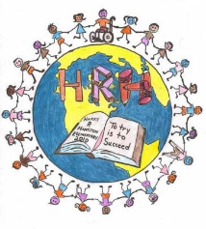
Harry R Hamilton 2023-2024
Grade One Supply list

❏ blue plastic duotang with pockets (front and back)
❏ 3 paper duo tangs (red, green, yellow)
❏ 3 jars of play doh
❏ 1 small yellow scribbler (½ lined/half blank pages)
❏ 4 white erasers
❏ 3 packs of pencils (sharpened)
❏ 6 white board markers
❏ 1 Pencil sharpener
❏ 1 small kit box or pencil case (no large boxes please)
❏ 3 boxes of crayons
❏ 2 packs of fine tip washable markers
❏ 4 large glue sticks
❏ 1 pair of scissors
❏ 1 pair of indoor sneakers
❏ 4 large ziploc bags
❏ Zipper messenger pouch
***Also; you may consider reusing any supplies from previous years.
Optional and much appreciated:
❏ box of tissues
❏ package of baby wipes
❏ 1 roll of paper towel

