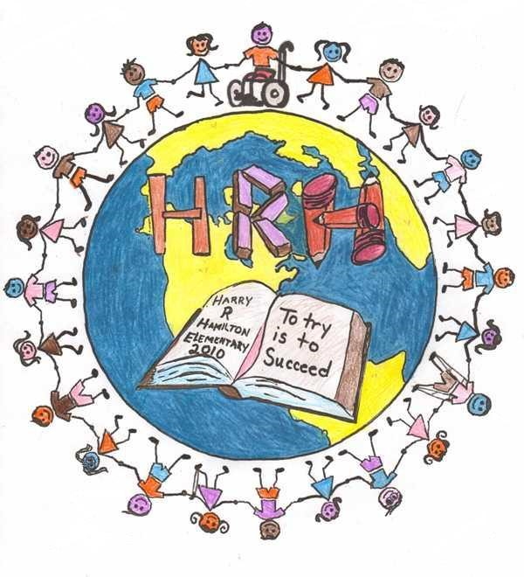
HARRY R. HAMILTON ELEMENTARY SCHOOL
GRADE 2 SUPPLY LIST
2026-2027

□ 1 regular 80 page scribbler (no coils, please)
□ 2 duotangs (1 yellow, 1 red)
□ 2 one-inch binders (different colors if possible)
□ 1 Courier Bag (Dollarstore)
□ 2 pocket folders (like duo-tangs, without the prongs)
□ 2 pkg. of 10 pencils (HB, only) sharpened, please do not label
□ 2 white erasers
□ 1 pair of scissors (sharp, pointed tip)
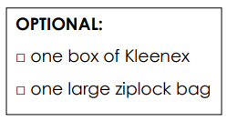
□ 4 large glue sticks (21g)
□ 1 box of 24 crayons
□ 1 package of 24 sharpened colored pencils
□ 1 package of thin tipped markers
□ 6 whiteboard markers
□ 1 pencil box (medium sized)
□ 1 clipboard
□ 1 Composition Book (Dollar Store - 200 pages / 24.7cm x 19cm)
□ Indoor footwear (non-marking soles)
□ 1 personal headset (inexpensive; not wireless; dollar store)

Please ensure that everything is labeled with your child’s name, as these items will be collected at the beginning of the school year for safe keeping. **Some items, mainly coloring supplies and glue sticks will need to be replenished throughout the school year as needed.

